Project Design Phase-II

Data Flow Diagram & User Stories

|  |  |
| --- | --- |
| Date | 16 October 2022 |
| Team ID | PNT2022TMID40862 |
| Project Name | Emerging Methods for Early Detection of Forest Fire |
| Maximum Marks | 4 Marks |

# Data Flow Diagrams:

A Data Flow Diagram (DFD) is a traditional visual representation of the information flows within a system. A neat and clear DFD can depict the right amount of the system requirement graphically. It shows how data enters and leaves the system, what changes the information, and where data is stored.

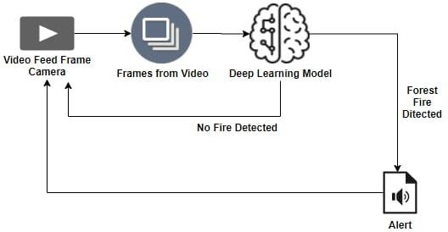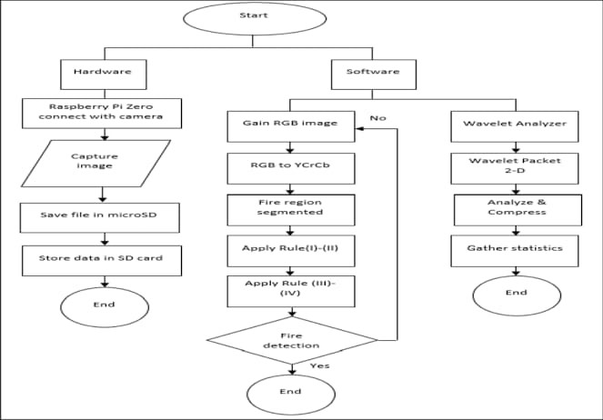

# User Stories

|  |  |  |  |  |  |  |
| --- | --- | --- | --- | --- | --- | --- |
| **User Type** | **Functional Requirement (Epic)** | **User Story Number** | **User Story / Task** | **Acceptance criteria** | **Priority** | **Release** |
| Forest Office Control Room (Normal times) | Surveillance | USN-1 | The camera watches the activities in forest area and feed the video to forest office control room | The user gets the knowledge what is happening in forest and be  alert | Medium | Sprint-2 |
| Fire Department | Being Alerted by Alarm | USN-2 | As a user, they will be alerted earlier or at the starting stage of Forest Fire and location can be shared | Due to the early alert received , the fire department can arrive to the fire spot early and  control forest fire easily | High | Sprint-1 |
| Police Patrol Control Room | Being Alerted by Alarm | USN-3 | As a user, they will be alerted earlier or at starting stage of Forest Fire with location | Due to the early alert received, the police patrol can arrive to fire spot earlier and help to evacuate nearby villages , save tribal peoples , sealing certain areas to prevent the unwanted entry of outsiders into  danger zone | High | Sprint-1 |
| Forest Office Control Room  (In case of Forest Fire Alert) | Being Alerted by Alarm | USN-4 | As a user, they will be alerted earlier or at starting stage of Forest Fire with location | Due to the early alert received, the forest department can arrive earlier to fire spot and protect nearby tribal people, nearby villagers and also animals as  possible | High | Sprint-1 |